How to modify the Estimated Ship Date (ESD)

- Navigate to the website. Login.

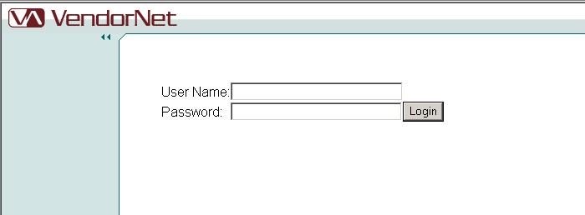

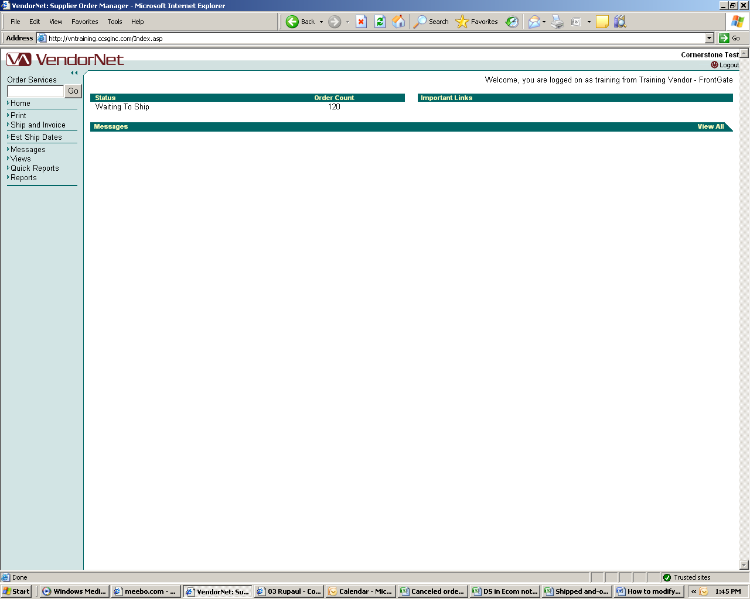

- Click on “Est Ship Dates”

- You should receive a Criteria box as a pop-up (see below).

If you do not receive this box, please check your system for firewalls and pop-up blockers prior to contacting the Vendor Technologies Group.

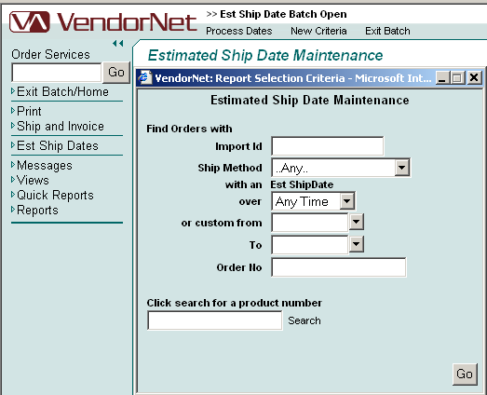

You may choose to search by Order Number or by Product Number.

Order number – You will need to enter the full 12 digit order number into the “Order No” box.

Product number – Type in the product number. It can be the catalog item number or your item number.

- Once you have entered your criteria, click “Go”.

- When the main screen refreshes, it will display the information matching the criteria you selected. In this example, I chose to search by Product Number. The program is displaying all orders with the item I requested.

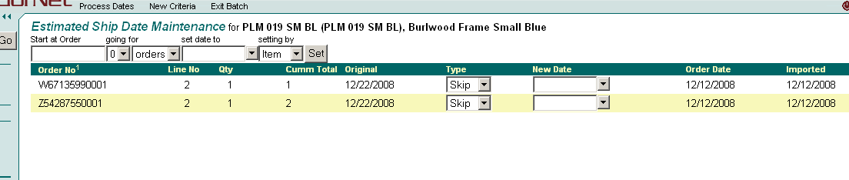

- You may update the orders individually or, if you need to update all with the same information, you can use the fields found just below the “Estimated Ship Date Maintenance” header.

In this example, I have chosen to start at the first order. I clicked on “Start at Order” (red arrow) and then on the first order number “W67135990001”. By doing so, the program auto-filled the “Start at Order” field for me. It also changed the “going for” field to equal the number of orders in the batch. You may change the number of orders through the drop down (blue arrow).

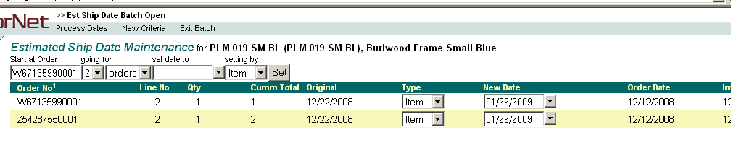

- Once you’ve entered the starting order, and how many orders you wish to change, you’ll need to enter the date in the “set date to” field. Please keep in mind that you can only enter a future date into this field.

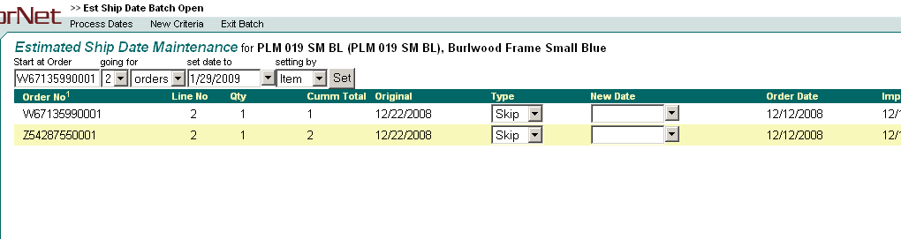

- After you’ve entered the date, click “set”. The information will, then, be populated in the “New Date” field.

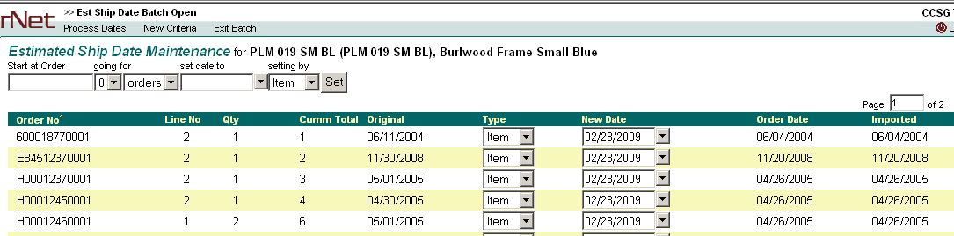

- Once you’ve verified the information, click “Process Dates” (next to the VendorNet logo). You will receive a pop up asking if you are sure you wish to proceed. Provided that you are sure, click “OK”.

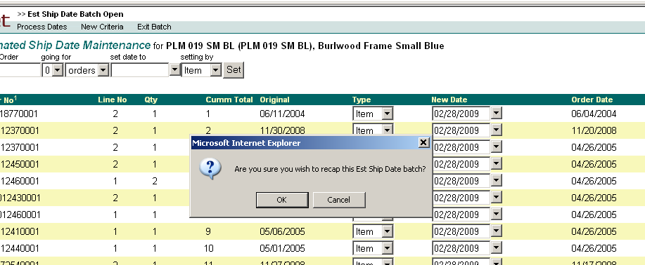

- The program will take you to a recap screen. Verify the information displayed.

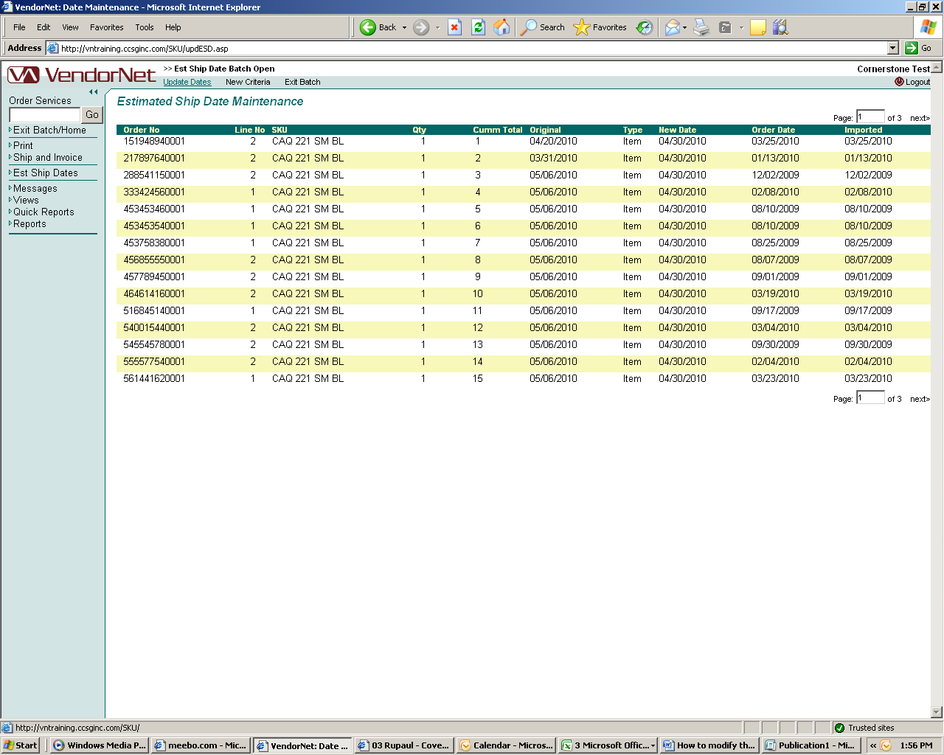

Once you are ready to submit the information, click on “Update Dates”.

Click “OK” to process the batch.

If you require assistance, please contact the Vendor Technologies Group (VTG@cornerstonebrands.com).

